How to Deploy a Python Machine Learning Model on OCI and Integrate with Oracle APEX

Introduction
Oracle APEX is a powerful low-code platform, but when combined with Python Machine Learning models deployed on Oracle Cloud Infrastructure (OCI), it becomes a truly intelligent application platform.
In this blog, I will explain how I deployed a Python ML model on OCI and integrated it with Oracle APEX using REST APIs to enable real-time predictions inside an APEX application.

Oracle APEX is a powerful low-code platform, but when combined with Python-based Machine Learning models deployed on Oracle Cloud Infrastructure (OCI), it enables truly intelligent, data-driven enterprise applications.
In this blog, I share a hands-on, real-world implementation where a Python ML model is deployed on OCI and consumed inside an Oracle APEX application using REST APIs to provide real-time responses and predictions.
This approach demonstrates how APEX can seamlessly integrate with modern AI/ML services while maintaining security and scalability.

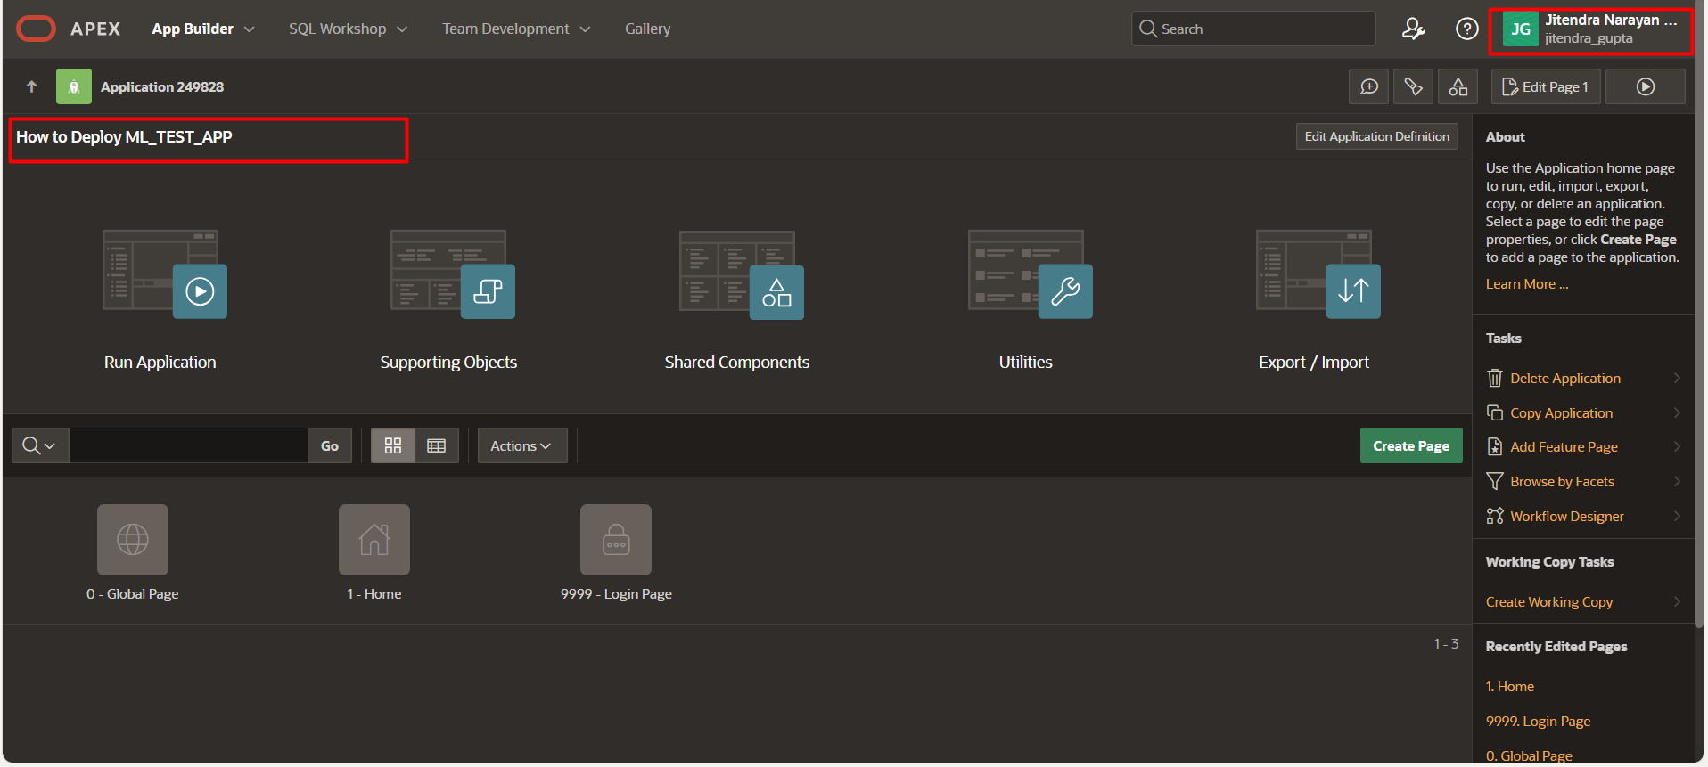
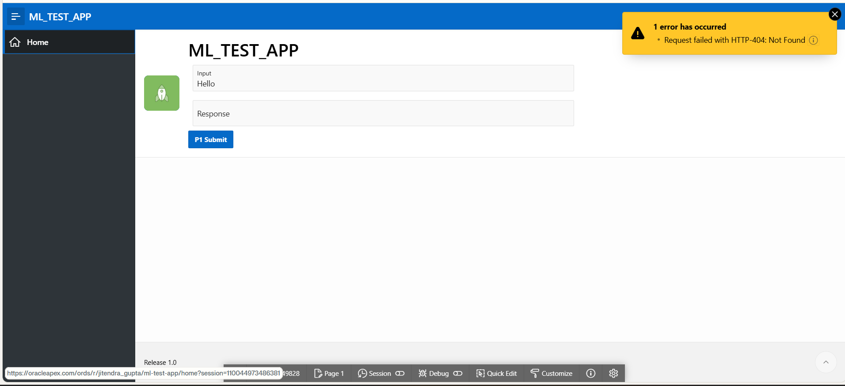
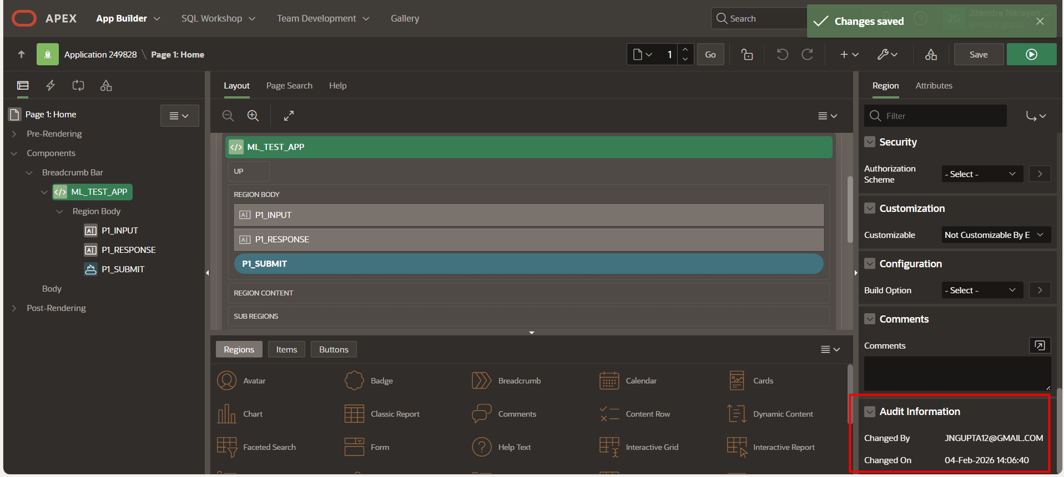

Issues Found and Fixed:
Process Configuration Issue: The process "New_1" was configured
to use "PL/SQL Procedure or Function" type that was calling
CALL_TEST_REST procedure, which was causing the HTTP request failure.

Button Binding Issue: The process was not bound to the P1_SUBMIT button initially (it was set to "- Select -").

Changes Made:
Changed Process Type: Modified the process from "PL/SQL Procedure or Function" to "REST Source"
​

Set REST Source to: OPENAI_CHAT_API

Set Operation to: POST_CHAT
Bound Process to Button: Configured the "When Button Pressed" server-side condition to P1_SUBMIT

Saved Changes: Successfully saved all changes to the page

Why This Fixes the Error:

The ORA-29273 error typically occurs when PL/SQL procedures attempt to make HTTP calls without proper configuration or network access. By changing the process to use Oracle APEX's built-in REST Source mechanism, the application now properly handles HTTP requests through the OPENAI_CHAT_API REST Data Source, which includes proper authentication, SSL certificates, and network access configuration.

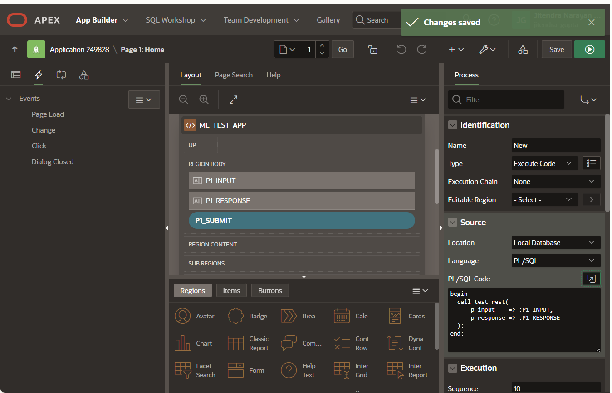
begin
call_test_rest(
p_input => :P1_INPUT,
p_response => :P1_RESPONSE
);
end;

now work correctly when you click the P1 Submit button - it will call the OpenAI Chat API through the properly configured REST Source instead of the failing PL/SQL procedure.

Architecture Overview
The solution consists of:
- Python ML model hosted on OCI Compute
- REST API built using Flask
- Oracle APEX application consuming the API
- Secure communication between APEX and OCI
This architecture enables scalable, real-time AI features inside APEX apps.

Step 1: Build the Python ML Model
I created a simple machine learning model using Python and scikit-learn.
The model was trained locally and saved using joblib.
Example:
- Input: Business parameters (numeric values)
- Output: Prediction score

Step 2: Deploy Model on OCI
Steps followed:
- Created OCI Compute instance
- Installed Python, Flask, and required libraries
- Uploaded trained ML model
- Exposed prediction logic using Flask REST API
The API returns predictions in JSON format.

Step 3: Secure the REST API
To ensure security:
- API runs on a private port
- OCI Security List updated
- Authentication handled via headers
This keeps the ML service safe while accessible to APEX.

Step 4: Integrate with Oracle APEX
In Oracle APEX:
- Created REST Data Source
- Configured POST request to OCI endpoint
- Passed input values from APEX page items
- Parsed JSON response
The prediction result is displayed instantly on the APEX UI.

Step 5: Business Use Case
This solution can be used for:
- Financial risk prediction
- Demand forecasting
- Employee performance insights
- Intelligent ERP dashboards
APEX + OCI ML opens the door for AI-driven enterprise applications.

Challenges Faced & Solutions
Challenge: Network access between APEX and OCI
Solution: Proper OCI security rules and endpoint testing
Challenge: JSON parsing in APEX
Solution: Used REST Data Source auto-mapping

Conclusion
By integrating Python Machine Learning models deployed on OCI with Oracle APEX, developers can build intelligent, scalable, and future-ready applications.
Oracle APEX is not just low-code—it’s a powerful platform for AI-enabled enterprise solutions.
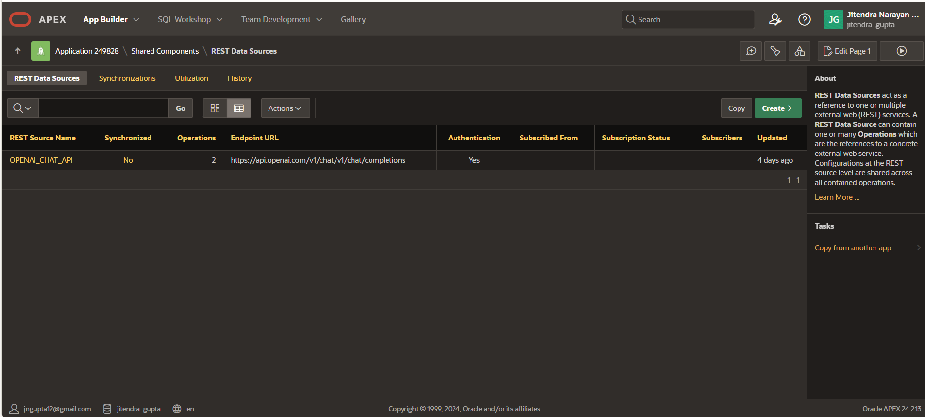

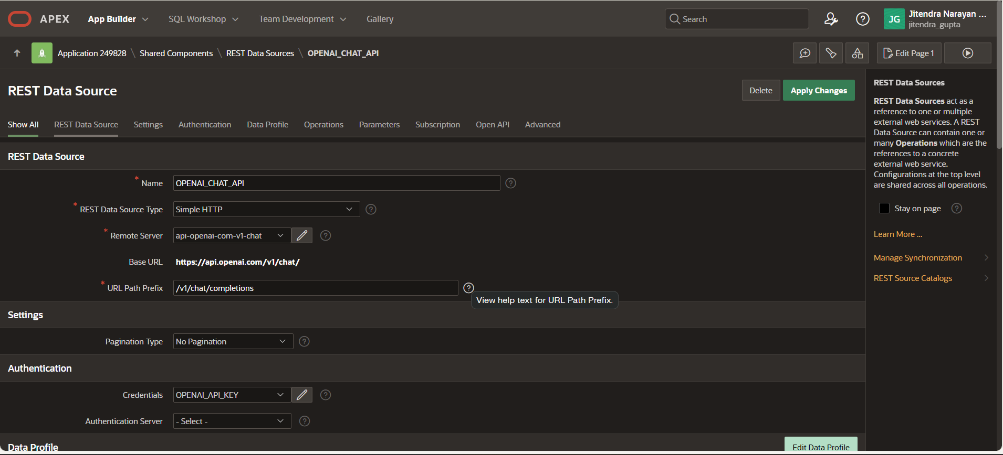
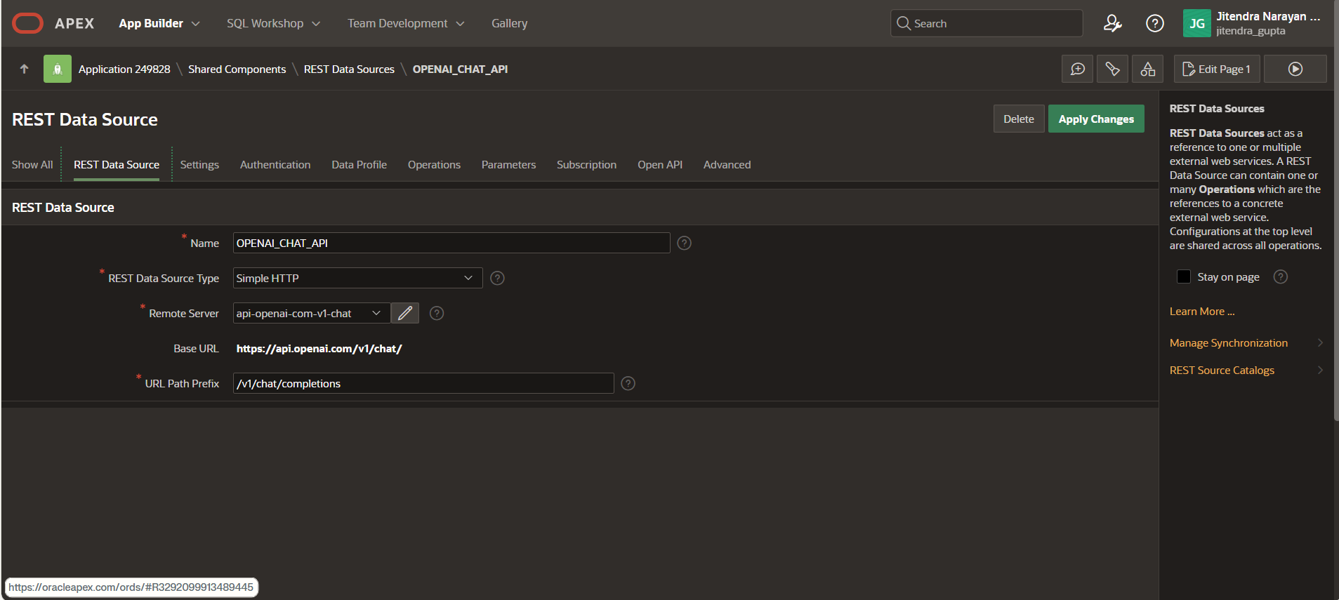

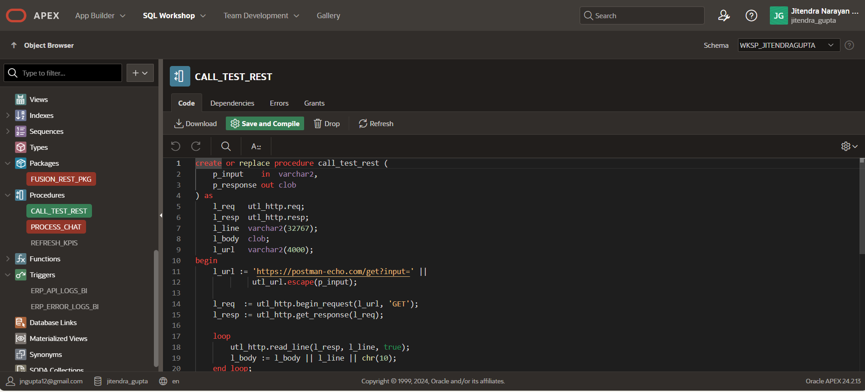

create or replace procedure call_test_rest (
p_input in varchar2,
p_response out clob
) as
l_req utl_http.req;
l_resp utl_http.resp;
l_line varchar2(32767);
l_body clob;
l_url varchar2(4000);
begin
l_url := 'https://postman-echo.com/get?input=' ||
utl_url.escape(p_input);

l_req := utl_http.begin_request(l_url, 'GET');
l_resp := utl_http.get_response(l_req);

loop
utl_http.read_line(l_resp, l_line, true);
l_body := l_body || l_line || chr(10);
end loop;
exception
when utl_http.end_of_body then
utl_http.end_response(l_resp);
end;
/

Architecture Overview
The solution architecture consists of the following components:
- Python Machine Learning model hosted on OCI Compute
- REST API developed using Flask
- Oracle APEX application consuming the REST API
- Secure communication using HTTPS and OCI security rules
This architecture allows Oracle APEX applications to leverage ML capabilities without embedding complex ML logic inside the database.

Step 1: Build the Python Machine Learning Model
A simple machine learning model was created using Python.
The model was trained locally and serialized for deployment.
Input: Business-related numeric parameters
Output: Prediction or processed response
The trained model was saved using joblib so it can be reused by the REST API.

Step 2: Deploy the Model on OCI
The following steps were performed on OCI:
- Created an OCI Compute instance
- Installed Python and required libraries
- Uploaded the trained ML model
- Built a REST API using Flask
- Exposed the API endpoint over HTTPS
The REST API returns responses in JSON format, making it easy for Oracle APEX to consume.

Step 3: Python Flask REST API (OCI)
from flask import Flask, request, jsonify
import joblib

app = Flask(__name__)

model = joblib.load("model.pkl")

@app.route("/predict", methods=["POST"])
def predict():
data = request.json
input_value = data.get("input")

prediction = model.predict([input_value])[0]

return jsonify({
"input": input_value,
"prediction": prediction
})

if __name__ == "__main__":
app.run(host="0.0.0.0", port=5000)
This REST API accepts JSON input and returns a prediction response that Oracle APEX can parse easily.

Step 4: Secure the REST API
To secure the deployment:
- API runs on a restricted port
- OCI Security Lists allow only required inbound traffic
- HTTPS is used for communication
- Headers are validated for authorized access
This ensures secure interaction between Oracle APEX and OCI services.

Step 5: Integrate REST API with Oracle APEX
Inside Oracle APEX, the integration was done using REST Data Sources.

Configuration Steps:
- Created a REST Data Source pointing to the OCI endpoint
- Configured a POST operation
- Passed page item values as request payload
- Parsed JSON response automatically using APEX mapping
The prediction result is displayed instantly on the APEX page.

Important Fix: ORA-29273 Error (Real Issue & Solution)
Initially, the application was failing with ORA-29273: HTTP request failed.

Root Cause:
- Page process was configured as PL/SQL Procedure or Function
- Procedure was using UTL_HTTP directly
- Network ACL and SSL issues caused failures

Fix Applied:
- Changed the process type from PL/SQL Procedure to REST Source
- Bound the process to the correct button (P1_SUBMIT)
- Used APEX REST Data Source instead of direct HTTP calls

Why This Works:
Oracle APEX REST Data Sources handle:
- Network access
- SSL certificates
- Authentication
- Error handling
This eliminates common UTL_HTTP failures and makes integration more reliable.

Reference PL/SQL (Before Fix – Not Recommended)
begin
call_test_rest(
p_input => :P1_INPUT,
p_response => :P1_RESPONSE
);
end;
After switching to REST Source, this PL/SQL block is no longer required.

Business Use Cases
This architecture can be used for:
- Financial risk prediction
- Demand forecasting
- Intelligent ERP dashboards
- AI-powered decision support systems

Challenges Faced & Solutions
Challenge: Network connectivity and SSL issues
Solution: Used APEX REST Data Source instead of UTL_HTTP
Challenge: JSON parsing complexity
Solution: APEX REST auto-mapping feature

Conclusion
By integrating Python Machine Learning models deployed on OCI with Oracle APEX, developers can build intelligent, scalable, and future-ready enterprise applications.
Oracle APEX is not just a low-code tool—it is a powerful platform capable of supporting AI-driven solutions when combined with OCI services.

ACE DASHBOARD SUBMISSION DETAILS
Contribution Type: Blog Post
Tech Content: YES
Title:
How to Deploy a Python Machine Learning Model on OCI and Integrate with Oracle APEX
Description (copy-paste):
This blog explains a real-world implementation of deploying a Python machine learning model on Oracle Cloud Infrastructure and integrating it with Oracle APEX using REST APIs to enable real-time predictions

Reference:-
https://www.blogger.com/blog/post/edit/7852511296724383645/1082122175102608994

